So we have finished almost the basic mechanism of our Game so now we need to create the user interface element , game over scene and our menu scene
So now we need to do those thing and our basic mechanism is ready
So in this lesson we are goiung to do organizing stuff
Organizing our code UI manager and Game Manager and then we gonna slowly create our menus and retry buttons and panels and all that

So we are going to create two manager one is Game Manager and another is UI Manager
So UI manager will be responsible for all our user interface elements like it will organize our buttons , the text and score text and all that stuff
and our game manger will control the whole game and it willl direct the UI manager what to do When to actually create this animation , when to show those text and buttons
that's all the game manager will do
So first of all create the UI manager
whenever you create a scripty by add component method it is created in assets folder we need to drag and drop it in script folder to organize our project

Lets do some UI stuff first of all
So we all gonna do when our game will be in position to start that measn before the game is started we need top show one text that will say tap to start
We need to tap on our screen to start our game and that text will blink
That means that it will be dissappeared and appeared
So we need ot create our effect here
So first we go to Create=> UI => Legacy => text
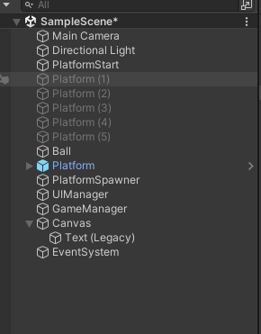
Now you will see that when you add this in your heirarchy then there are two IOA will be guaranteed that is Canvas and EventSystem get created for us as shown below
3:40
so this test is a convas
Nowe we reset the text position
Noiw text will come in form of our game panel
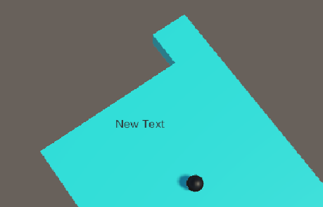
as sheon below

We want that ui to screen resolution independent so that this thing UI works in every mobile in device ans screen size
What is we need to select the canvas
and then in inspector panel
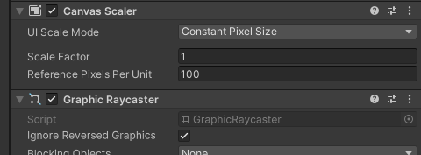

You can go to Canvas scaler subpanel snd if you set UI scale mode to Constant Pixel size then the image will be of constant soize irrespective of screen' but if you set it to scale with screen size then its size will be changed according to the size of the device
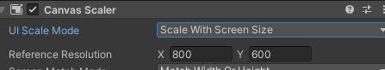

Now we need ot select the reference resolution that measn the resulutiuon for which we are originally building the game
We will set it to 480 X 800 resolution we have used in our game panel as shown below

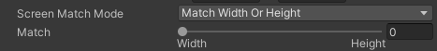

if we set it to 0 then when the resolution change sthen the object try to mathced ith the width of the supposed object inside the new resolution and if set to 1 then matches according to the height and if to 0.5 then according to both

Now our canvas is screen resolution independent (who knows maybe quality is maintained)

So now we need to select our text so that it looks like what we want
Now double click on the text to focus on it in the scene panel
choose the rectangle transform tool to modify its bounding box as shoen below

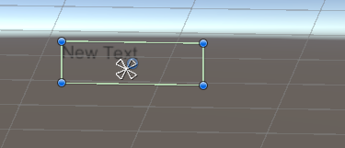

Ifg you place the bounding box center on the canavas center then blue line will start from that point

Now we rename the text in heirarchy to the tapText as sheon below

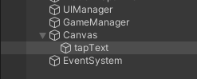

and hten in its inspector set the text to Tap to text

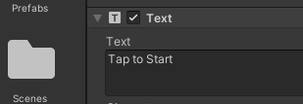

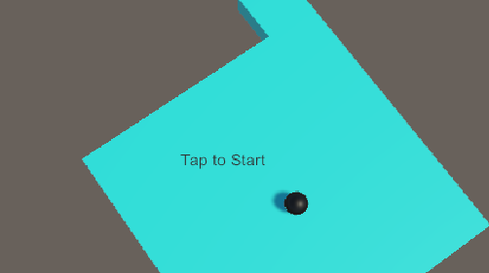

and now in alignment we set the text to vertically aand horizontally center

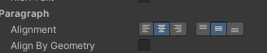

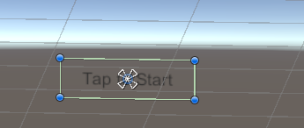

Now we change the font size of teh text so that it will look bigger

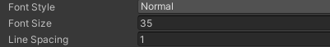

and move it so tht it looks like below

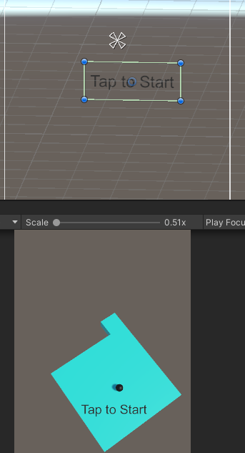

We can also change the font style to bold but teacher thimnks that normal will be good also
We can change the color but we keep it black

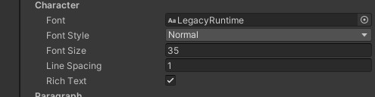

So what we need to add animation to it so that it will blink on the screen
So go to windows menus and then go to Animator tab

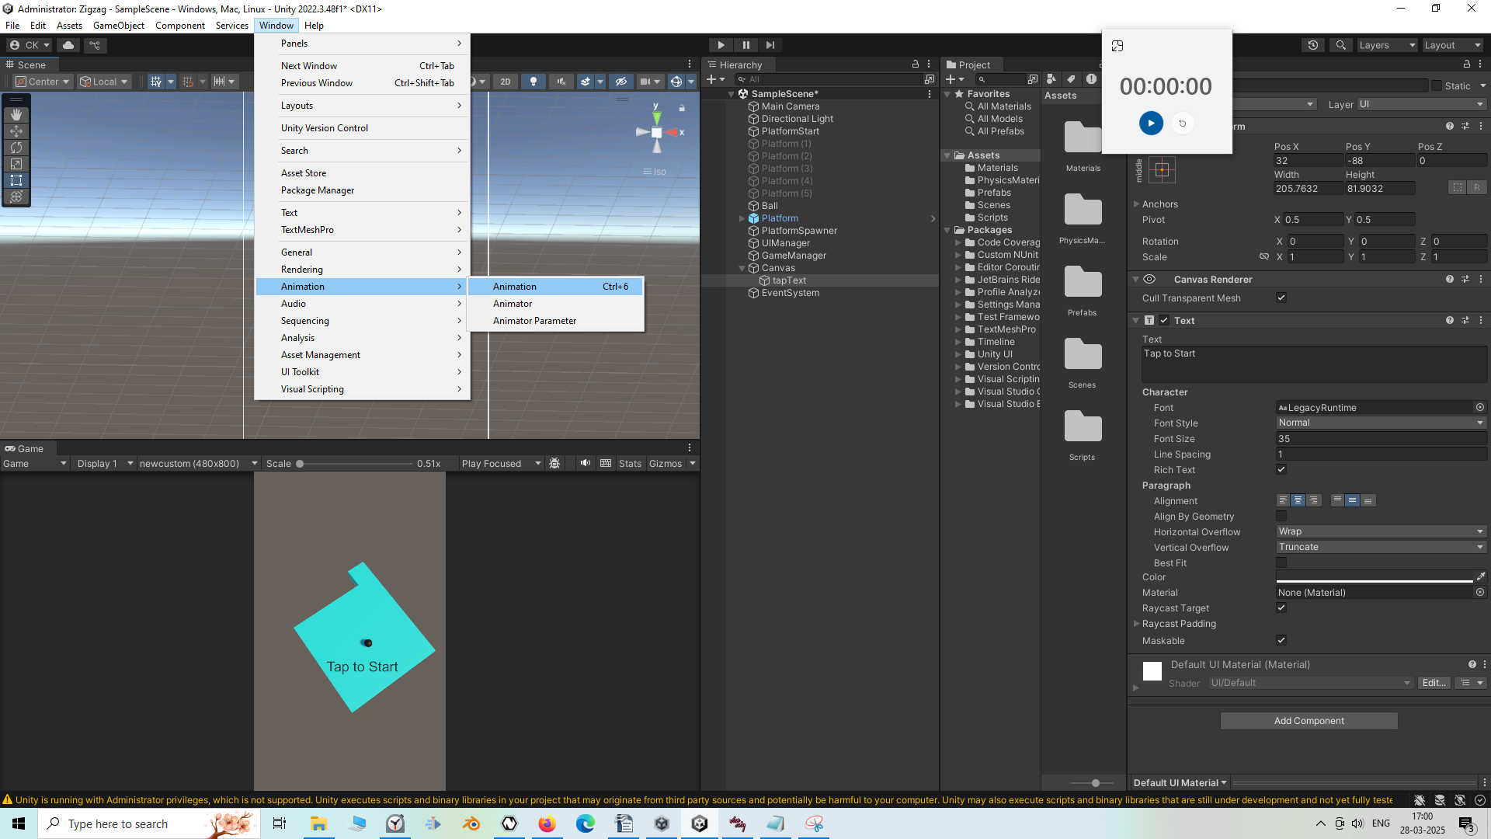
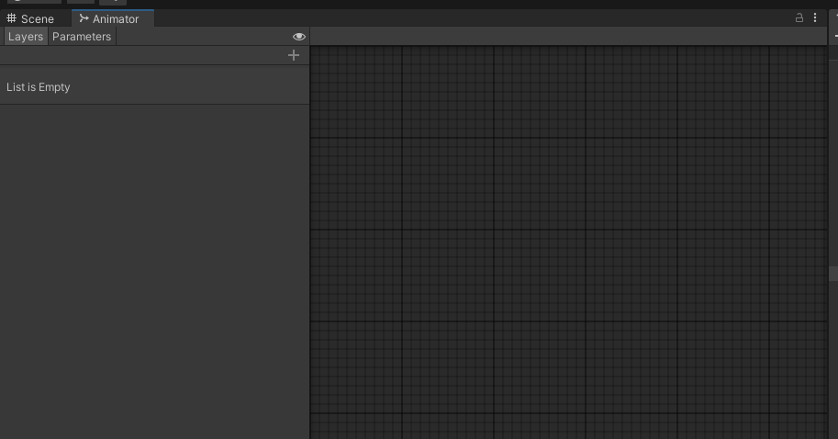
Now Animator window will be shown above beside the Scene tab
8:10
and now again go to window and then to Animation
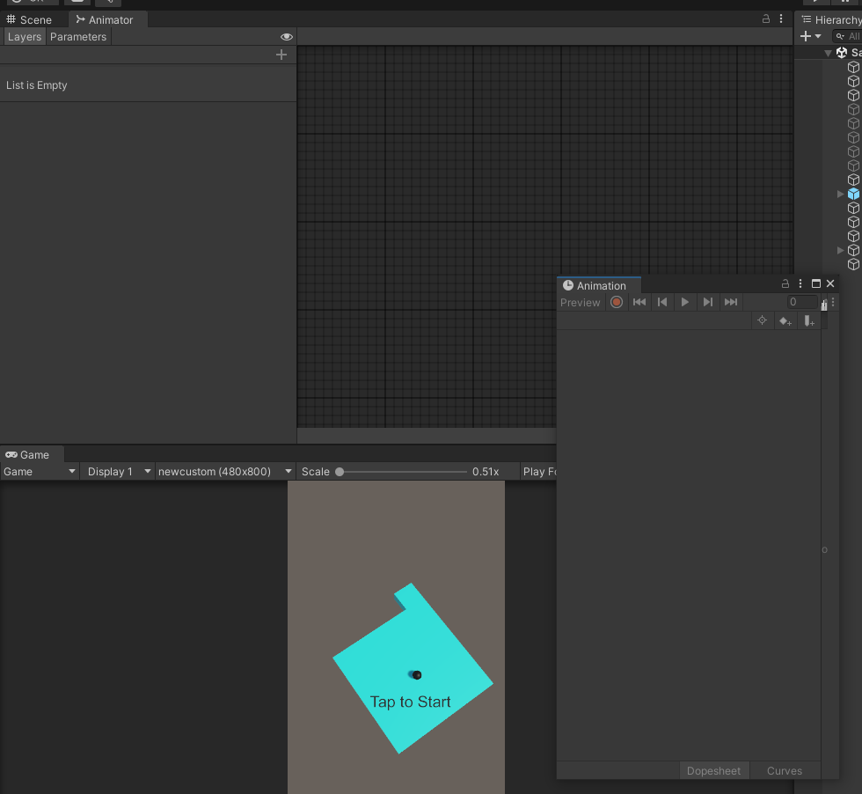
Now above is the Animator window and Animation window
Now by drag and drop it beside the Animator window as shown above
Now select out Tap to text IOA ib the heirarchy and then in Animation window Create button appears like below Click on it
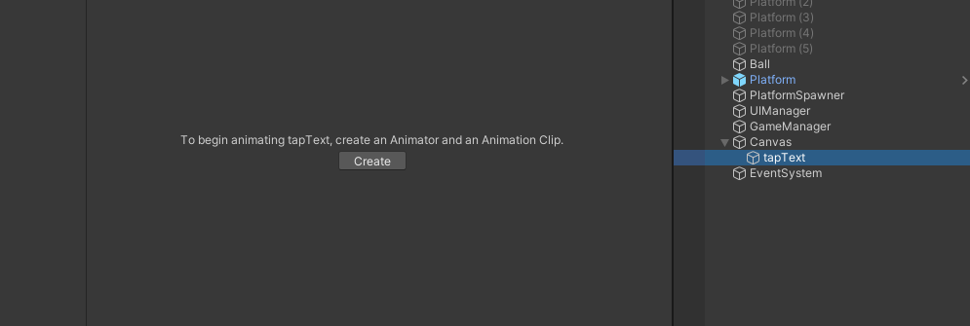
and then a browse window
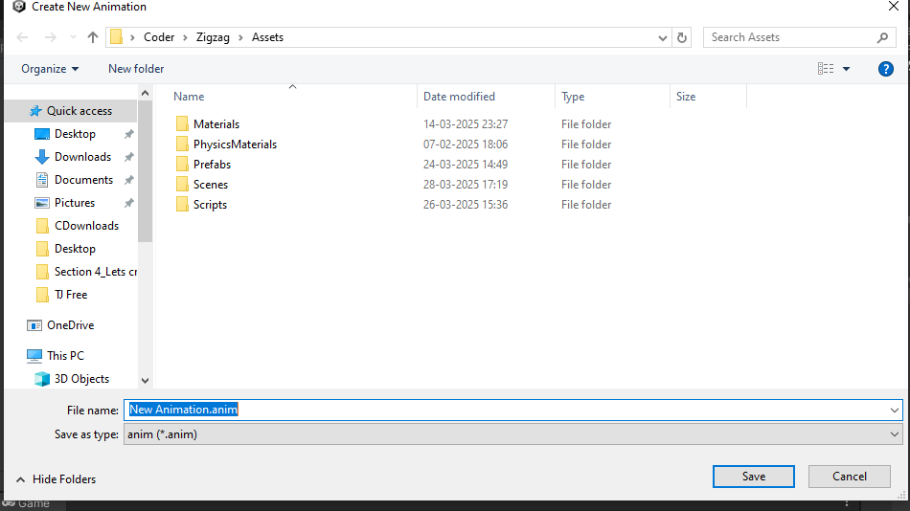

I think by default it opens in Assets folder (I think so )
We create afolder inside and then name it animation as shown below

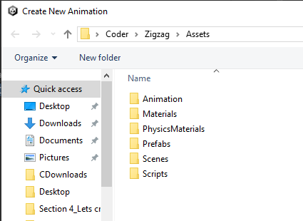

Now go inside Animation folder and then save the file in it and name it textBlink

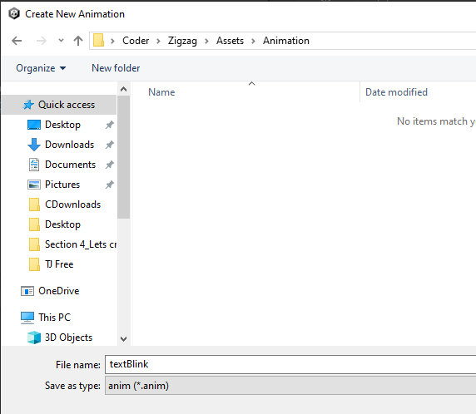

Noe click on save button Now you can see the textBlink in animation window as shown below

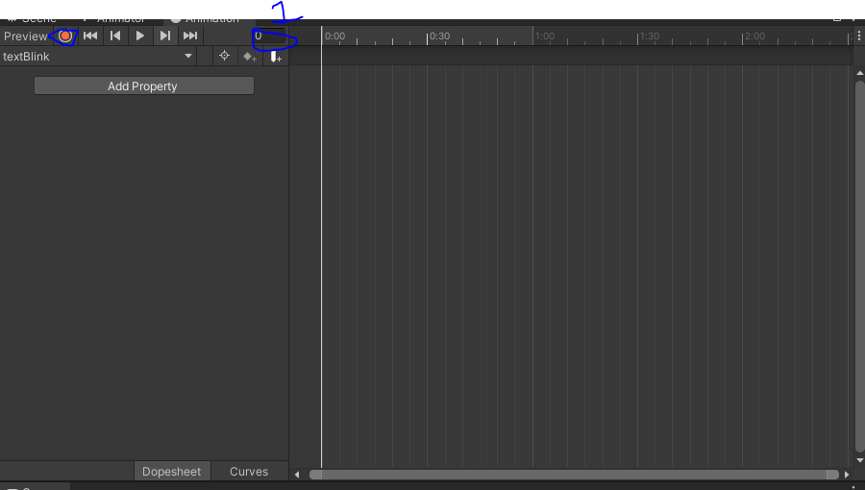

Now click on record button as marked above

after clicking on it everything you do here will be recorded as animation
If we want to make changes to the animation(I think that is being recorded) you need to go anpther frame showing in animation window

Now you can go to marked 1 where you can enter the number of the frame you wnat ot go to
So we go to 60 frame

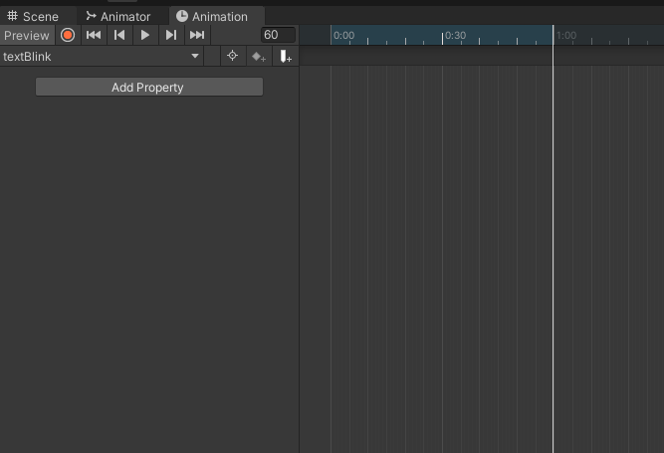

and then in 60 frame we want the text to completely fade(means we want to deccrease its alpha(who knows) and then again we want it to fully colored so that it will look like its blinking
Now in 60th frame we go to our color property of text
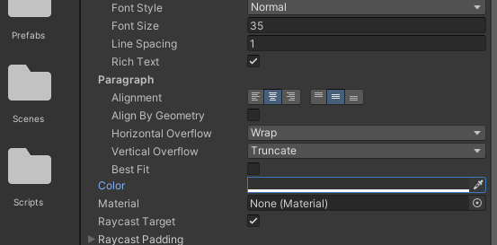

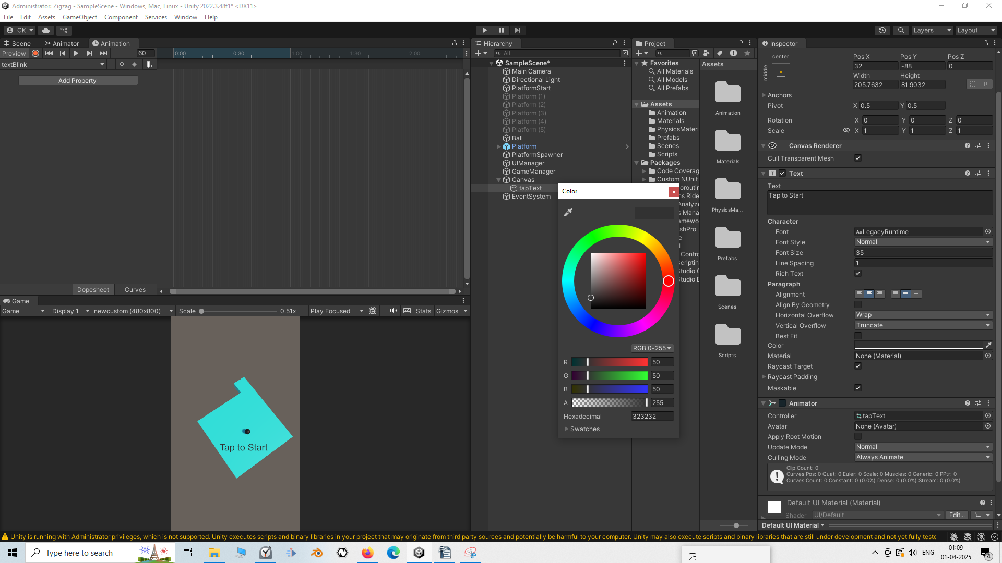

and now you can see the alpha value here now if you decrease it then tap text will become invisible
A the record button was pressed keyframes are formed in the timeline as shown below

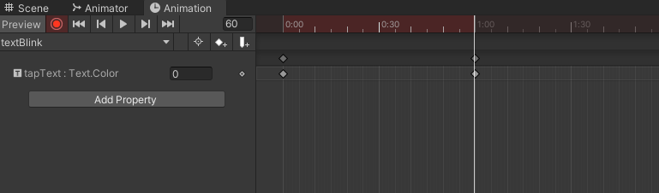
and now we want to again make our text color again to normal so we fitrst move to 60 frames more measn go to 120 frame and then make the alpha 255 full again

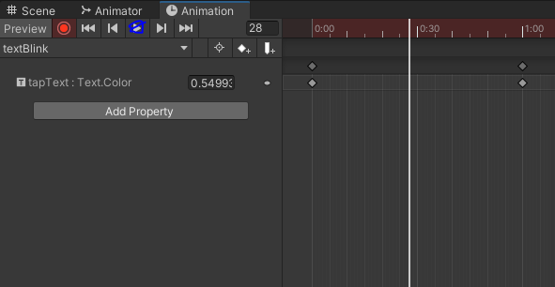

Now if we click on Play button as marked above
and now you can see that your text looks like it is blinking but you can see it is slow but if you want to make it faster
then you need to modify its sample rate but it is not showing in animation window so to show it we click on the marked below
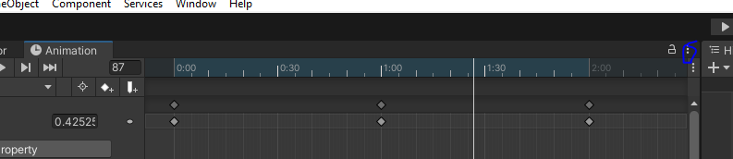
Now in new submenu click on show sample rate as shown below
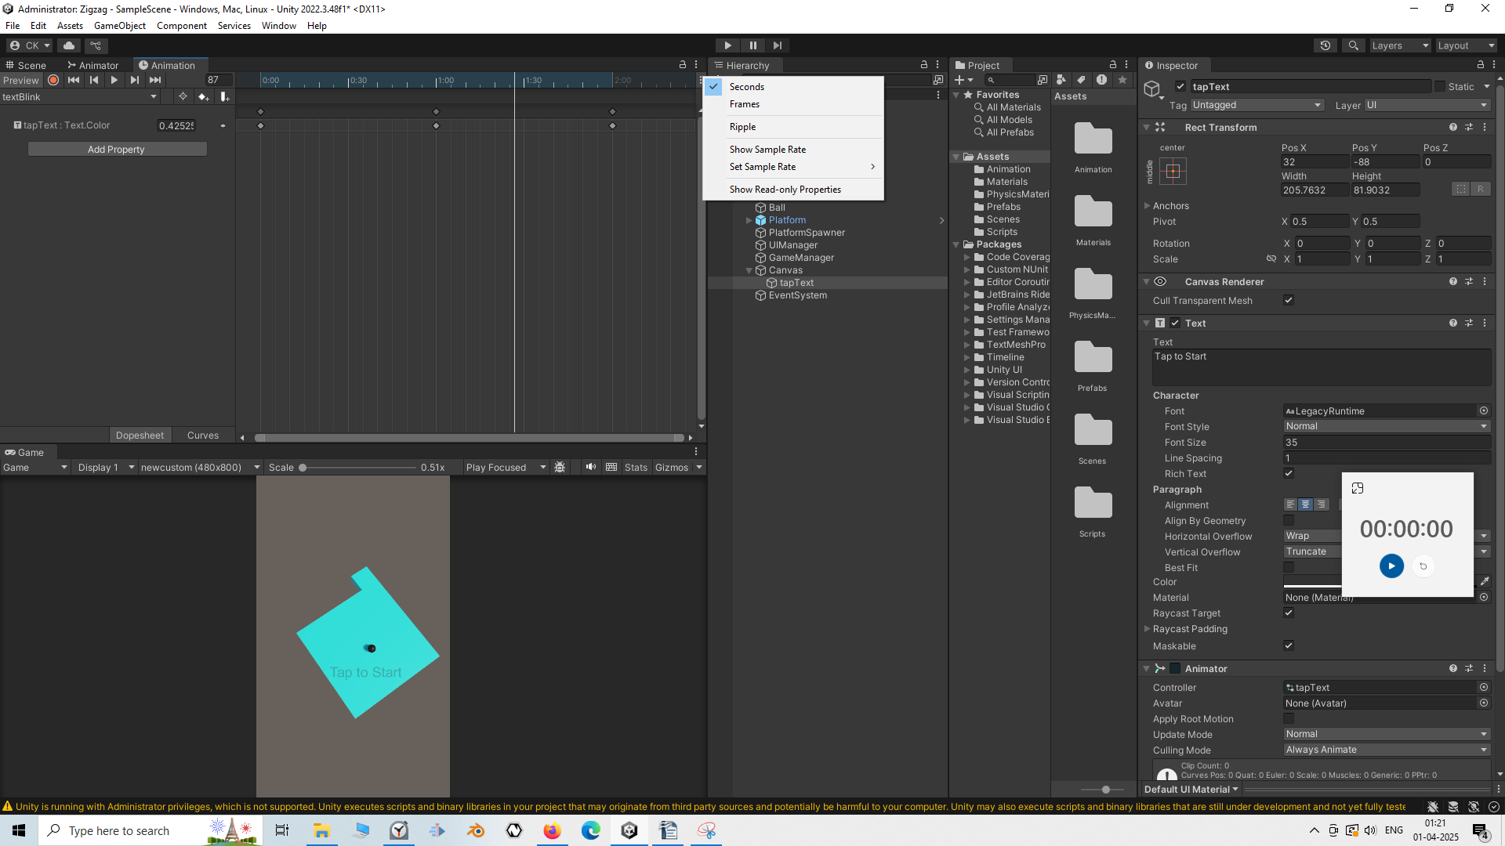
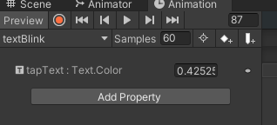

Now sample rate might be shown in the animation window Now it is saying our animation rate is 60 we set it to 120 so that its speed becomes double becauser of shrinkness of keyframes in timeline by half as shown below(maybe this works opposite of quantity)(who knows)

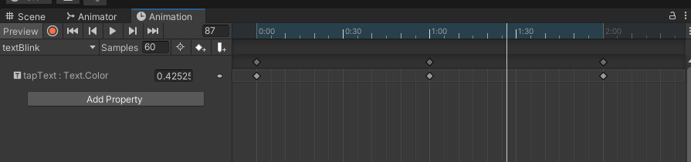
Before
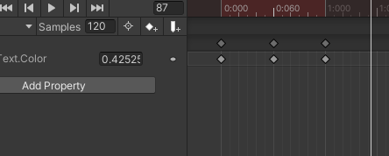

After
It will only bwork when record button is on.
Now we click on play button then animation will be faster and i this is what we want
13:30
Now when the game is played then it will start blinking
Now we can do is add a hgh score text and also game name in teh marked below

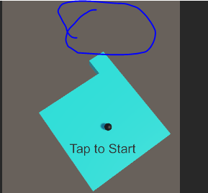

Whenver we start our game we want it to go downward and the game will start So there we will add another animation of tap to text such that it will go downward
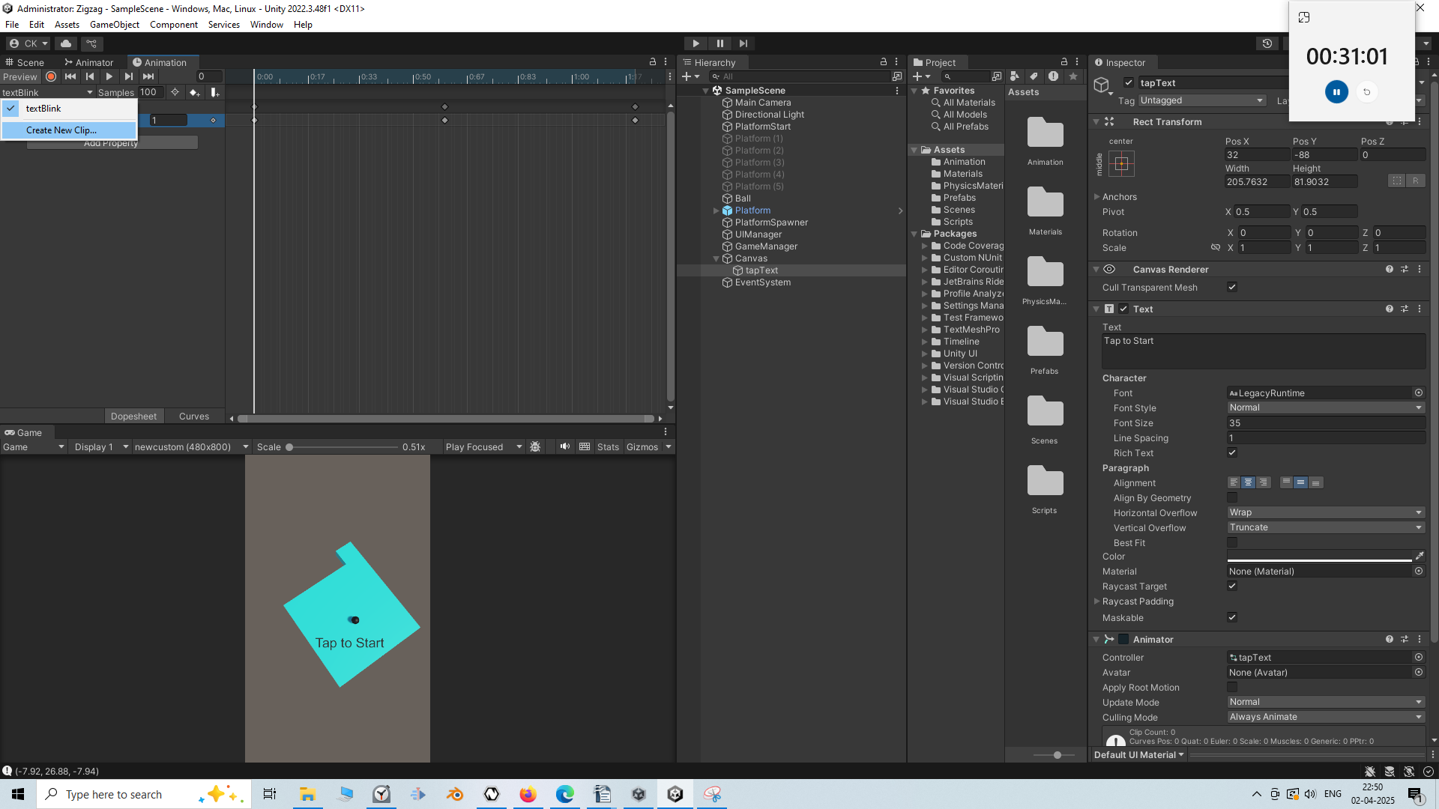
So now go to beside the name of the animation and then in submenu click on Create new clip to add another animation to the tap to text

and now go to animation and then creatte animation file that is downtext
this animation will put the text down
So on teh record button and go to 60th frame and then drag it to down the screen in the scene panel

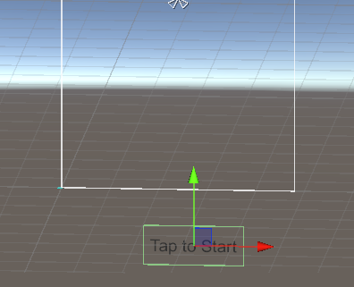

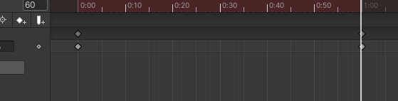

Now the text is moving downward we also want that the text should fade away

So we go to 60th frame and tehn make the alpha 0 and in 0th frame make the alpha full
So now there are two animation
one is of blinking
and another is of going downward and then fade out
Now when you play the game then blinking animation will be shown becuase it is the default animation (maybe because it was added first)

Now if we go to our Animator tab then

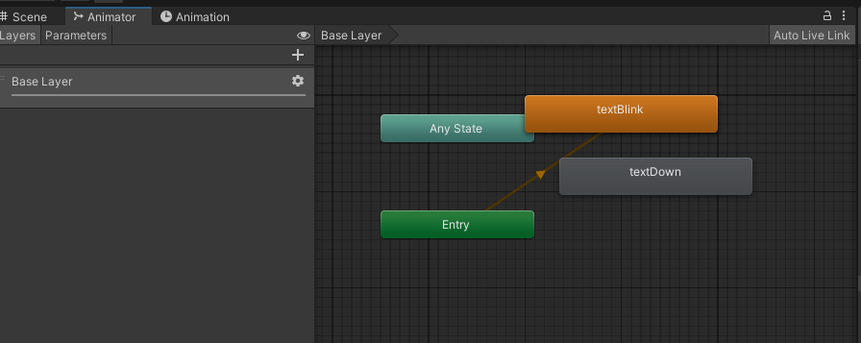
you can see the orange color on text blink and it is linked to Entry node it tell us that it is the defualt animation
Now to make the textDoen animation default right click on it and then in submenu click on
set as Layer default State
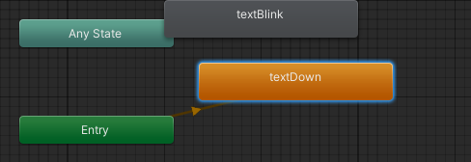

Now it will be the default animation as shown above

Now if i play the game then this time now the taptext now go downward and fade out
But for our game want that textBlink should be default
Now this is for our starttext or top text
Now in the next lesson we will make more UI stuff and organize our UI manager and our Gamemanger

